MCKV INSTITUTE OF ENGINEERING

Computer Science and Engineering – Data Science

***Name - Abhinaba Sarkar***

***Roll No. - BTECH/CSE-DS/2020/47***

**Assignment Number:** 10

**Assignment Number: 10(A)**

Problem Statement: Write a program in python to create a text file and write the text “Welcome to Python” in the file.

**Source Code:**

*f1 = open('text1.txt','w') #f1 is file object*

*f1.write('Welcome to Python')*

*f1.close()*

**Output:**

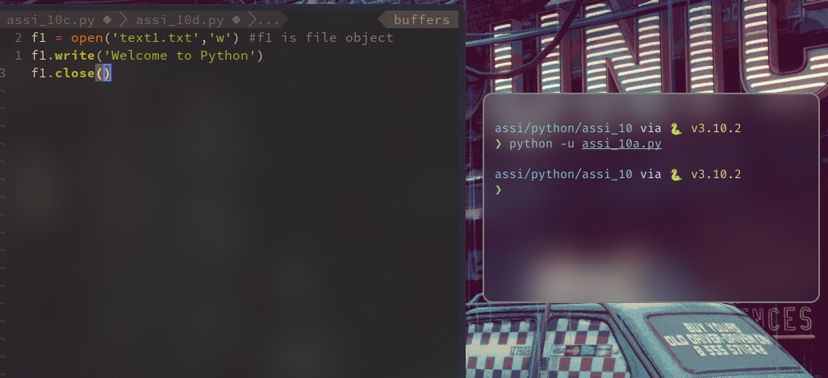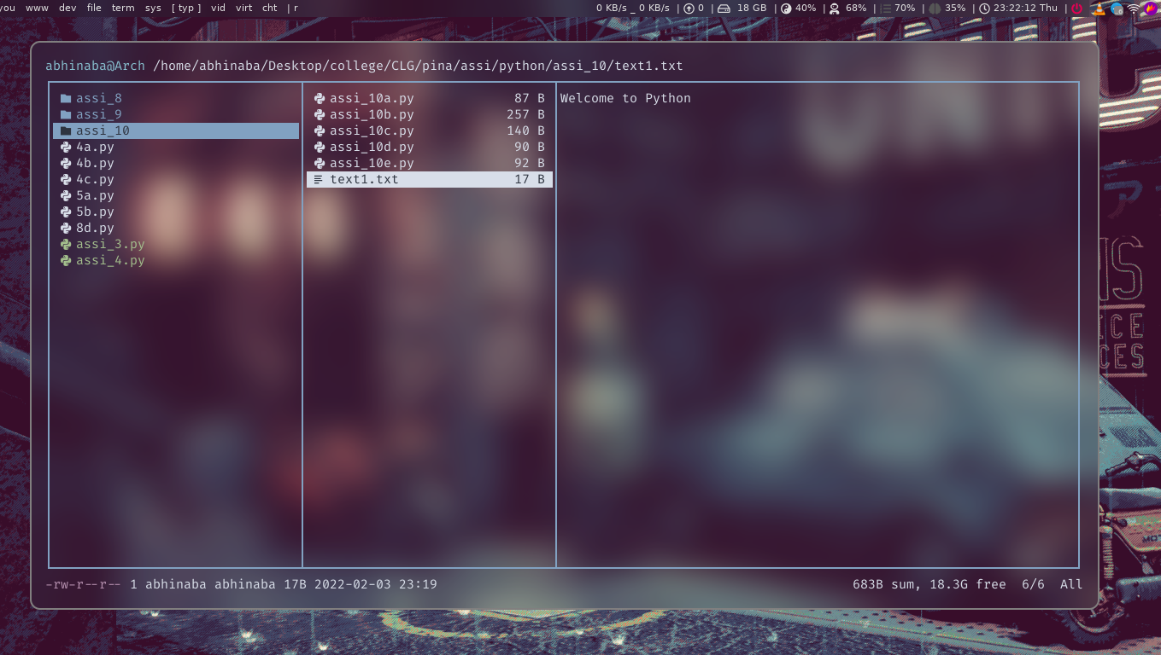

**Assignment No.: 10(B)**

Problem Statement : Write a program in python to store the first n prime numbers in text file.

**Source Code :**

*count = 0*

*f = open("text2.txt",'w')*

*n = int(input("Enter number: "))*

*i=2*

*while(count<n):*

*for j in range(2,i):*

*if(i%j == 0):*

*break*

*else:*

*count +=1*

*print(i,end=" ")*

*f.write(str(i) + ' ' )*

*i+=1*

*f.close()*

**Output :**

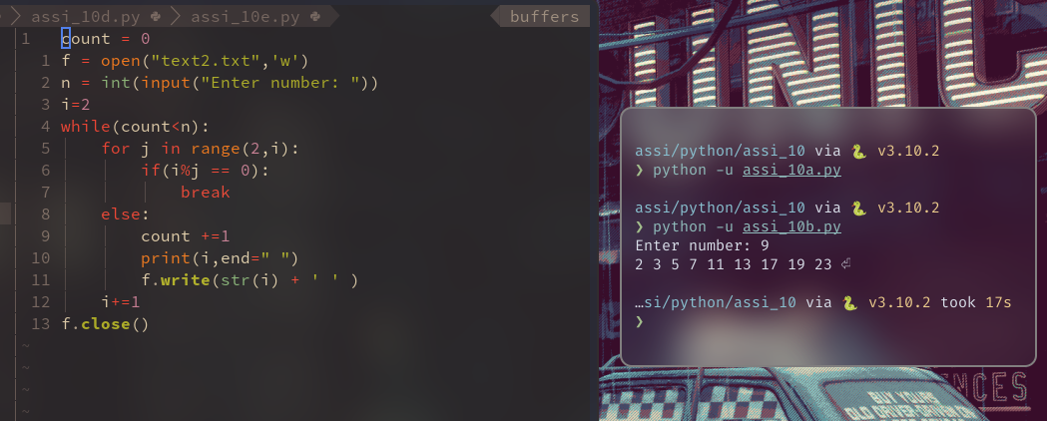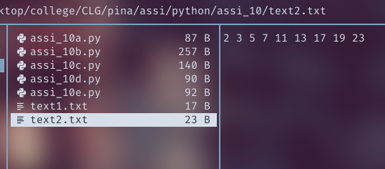

**Assignment Number: 10(C)**

Problem Statement: Write program in Python to store Fibonacci numbers between 0 to n, in a text file.

**Source Code:**

*a,b=0,1*

*n = open("text3.txt",'w')*

*m = int(input("Enter the number :"))*

*for i in range(m):*

*n.write(str(a) + ' ')*

*a,b=b,a+b*

*n.close()*

**Output:**

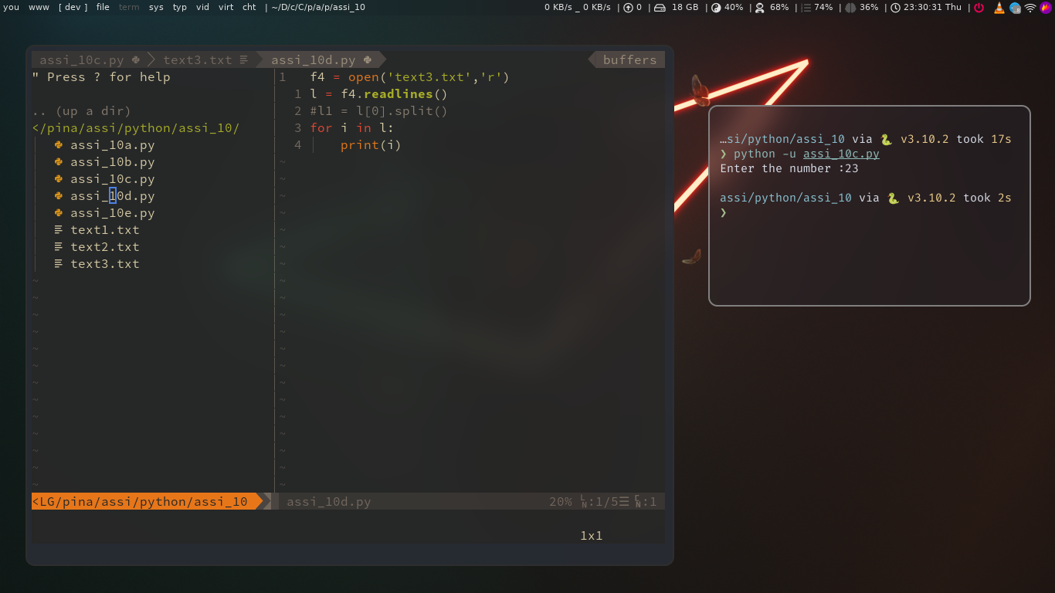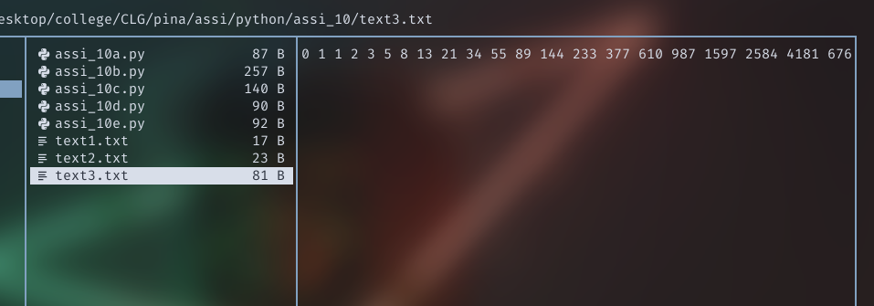

**Assignment Number: 10(D)**

Problem Statement: Write a program in Python to read line(s) of a text file and display the lines.

**Source Code:**

*f4 = open('text3.txt','r')*

*l = f4.readlines()*

*#l1 = l[0].split()*

*for i in l:*

*print(i)*

**Output:**

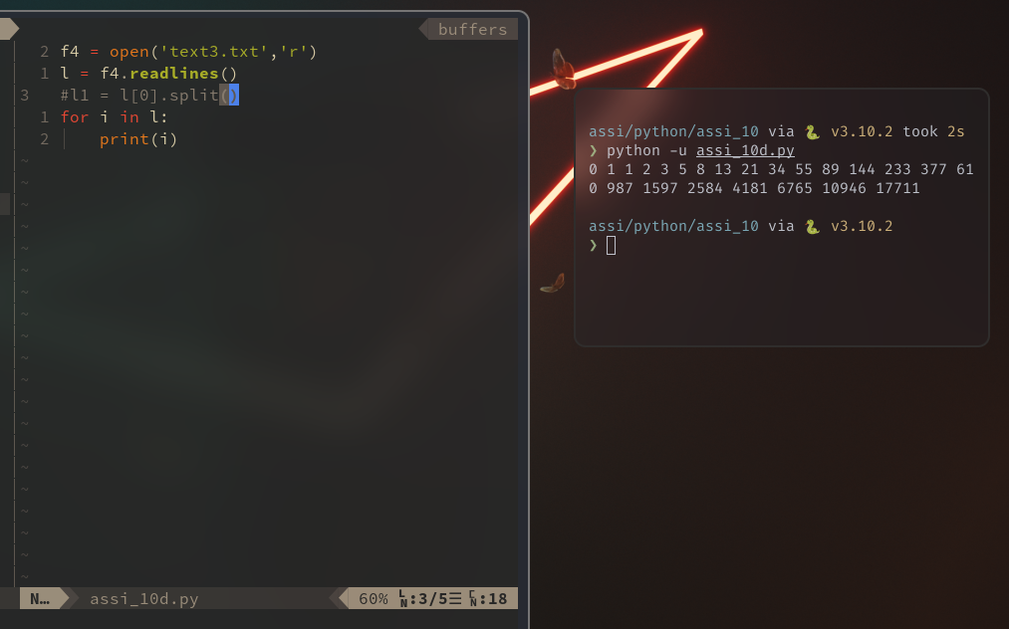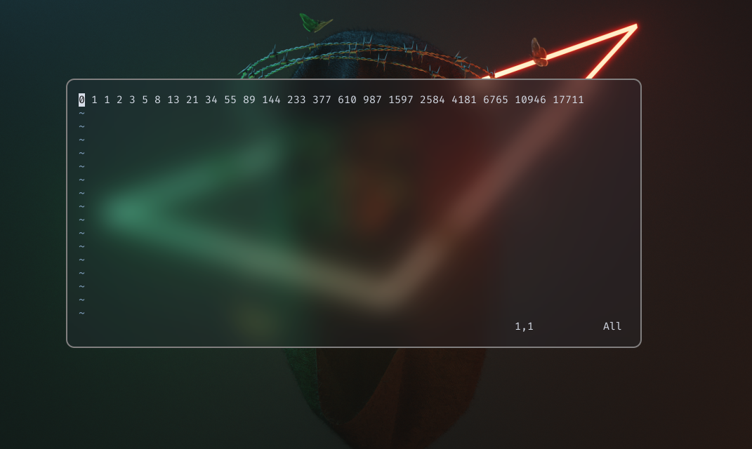

**Assignment Number:10(E)**

Problem Statement: Write a program in Python to find the size of a file.

**Source Code:**

*import os*

*size = os.path.getsize('text3.txt')*

*print('Size of the file is' , size , 'bytes')*

**Output:**

